How to fork files/repository and pull request

**Fork**: A fork is a copy of a repository. Forking a repository allows you to freely experiment with changes without affecting the original project.

Follow the below given steps to fork files/repository and pull request:-

**Step1**: Login into your Github account and search for the repository in which you want to fork.



**Step2**: After opening particular repository click “Fork” button

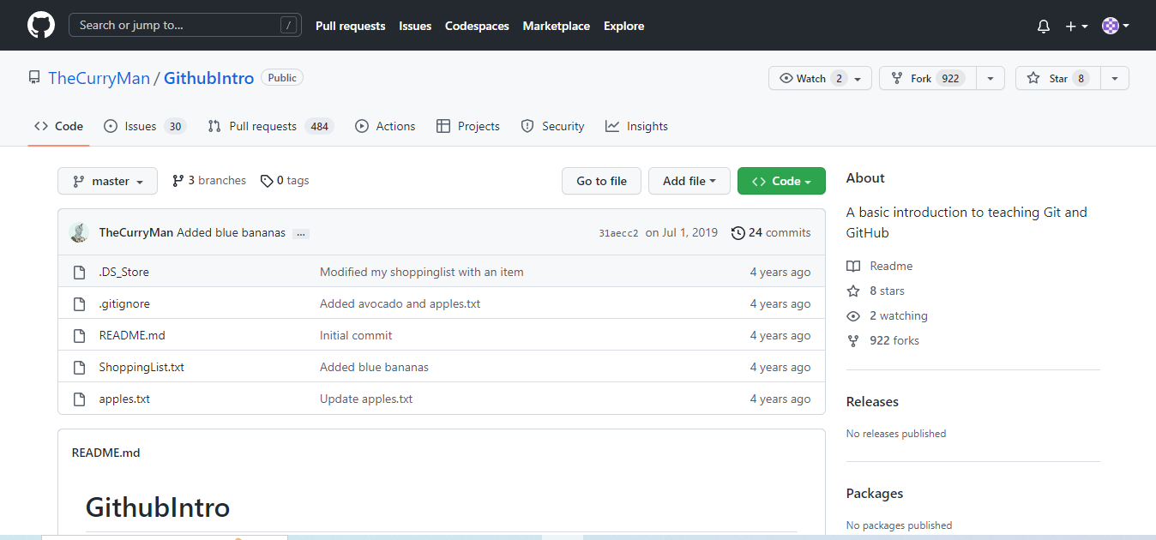

**Step3**: Enter repository name and click “Create fork”

**Step4**: We can create new file or can upload local files with help of “Add file” tab. 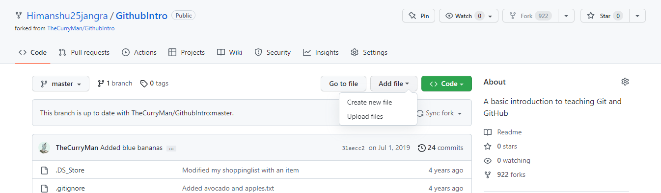

For editing existing file, we need to open the respective file and click edit symbol.

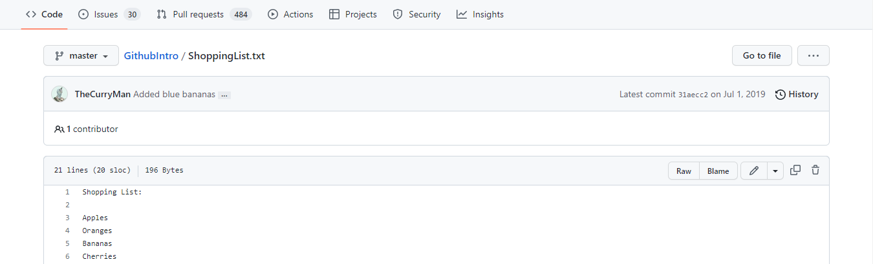

After creating/ editing or uploading file we can give description below and Commit all changes.

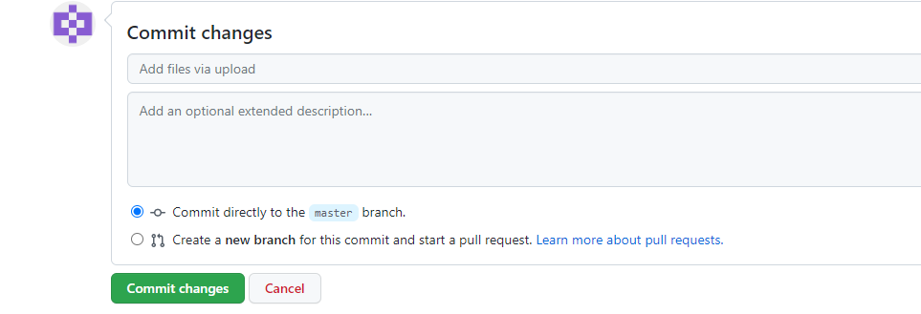

Now we have successfully made changes in the project with is copied by us. Now we need to pull a request so that the owner of the project gets notified that we have made changes in their project.

**Step5**: Creating New pull request.

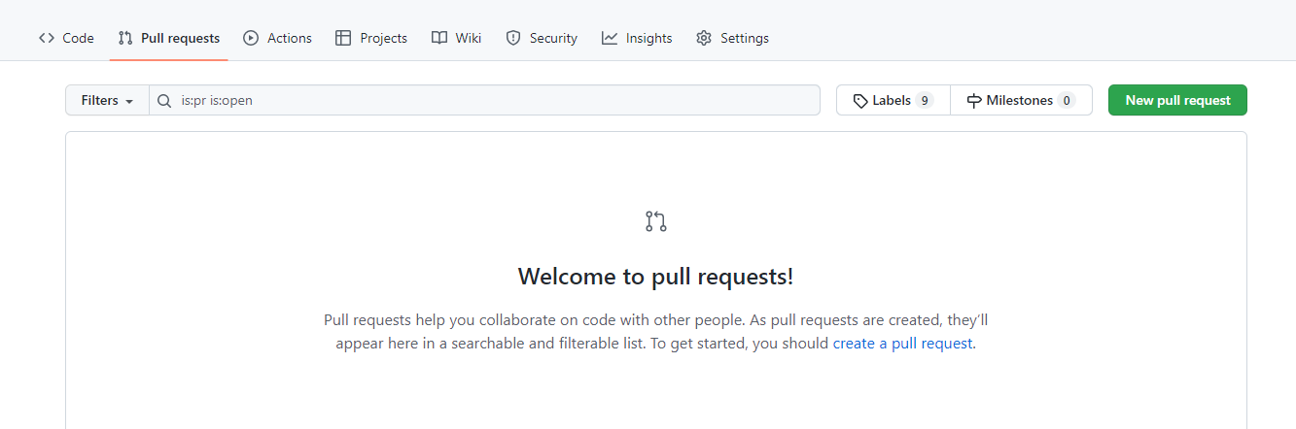

**Step6**: Before creating pull request we can give overview about changes made by us, and can proceed to “Create pull request”.

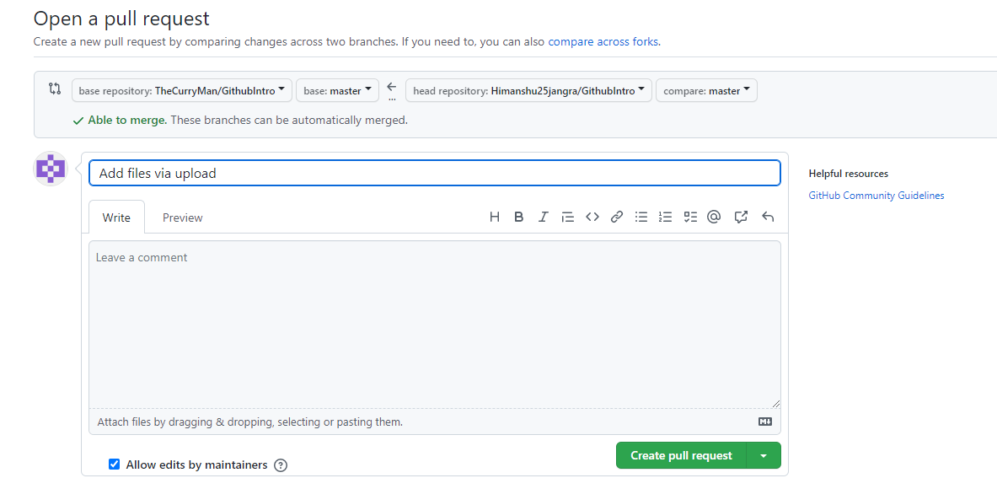

Owner can now check all the changes and files uploaded by us. If owner is satisfied with our work he will merge our work with their project.

